|  |  |
| --- | --- |
| TEAM ID | PNT2022TMD18761 |
| PROJECT TITLE | NEWS TRACKER APPLICATION |
| TEAM MEMBERS | VENKATA SAI SUMANTH KOVURU  PRASANTH KUMAR TELLA  KISHORE THALISETTY  LOKESH RACHURI |

 NEWS TRACKER APPLICATION

PROJECT

**PROJECT REPORT**

***Submitted by***

**KOVURU VENKATA SAI SUMANTH [19CS081]**

**TELLA PRASANTH KUMAR [19CS103]**

**THALISETTY KISHORE [19CS115]**

**RACHURI LOKESH [19CS104]**

***In partial fulfilment for the award of the degree Of***

**BACHELOR OF ENGINEERING**

**IN**

**COMPUTER SCIENCE AND ENGINEERING**

**MUTHAYAMMAL ENGINEERING COLLEGE (AUTONOMOUS)**

**RASIPURAM - 637 408, ANNA UNIVERSITY :: CHENNAI- 600 025**

**Project Report**

1. **INTRODUCTION** 
   1. Project Overview
   2. Purpose
2. **LITERATURE SURVEY**
   1. Existing problem
   2. References
   3. Problem Statement Definition
3. **IDEATION & PROPOSED SOLUTION**
   1. Empathy Map Canvas
   2. Ideation & Brainstorming
   3. Proposed Solution
   4. Problem Solution fit
4. **REQUIREMENT ANALYSIS**
   1. Functional requirement
   2. Non-Functional requirements
5. **PROJECT DESIGN**
   1. Data Flow Diagrams
   2. Solution & Technical Architecture
   3. User Stories
6. **PROJECT PLANNING & SCHEDULING**
   1. Sprint Planning & Estimation
   2. Sprint Delivery Schedule
   3. Reports from JIRA
7. **CODING & SOLUTIONING (Explain the features added in the project along with code)**
   1. Feature 1
   2. Feature 2
   3. Database Schema (if Applicable)
8. **TESTING** 
   1. Test Cases
   2. User Acceptance Testing
9. **RESULTS**

1. Performance Metrics

10.**ADVANTAGES & DISADVANTAGES**

11.**CONCLUSION**

12.**FUTURE SCOPE**

13. **APPENDIX**

Source Code

GitHub & Project Demo Link

# 1. INTRODUCTION

## 1.1 Project Overview

News Tracker is an application that primarily focuses on enhancing and optimizing the way of user interaction with the news stories. It is more user friendly in a way that a user can personalise his/her own interests in this application. The study process began with how other applications developed with respect to personalisation and giving users a curated content. This step allowed the study analysis identify the disadvantages and make it as advantages in this application. The idea of personalisation is that it keeps track of the user's interests and accordingly change the home page for the users to give them a personalised experience based on what they set as their preferences. The application also has an added advantage that any user using this application might not be able to feel discomfort as there are no advertisments which many applications failed to meet up the expectations of a user. The application stands out off the crowd in terms of personalisation, better search and able to view in multiple languages.

## 1.2 Purpose

News tracker serves the purpose ofdelivering a better application to the users and enhanced user experience and user interface. The ultimate purpose is giving the user a personalised application with an ability to better search and this application doesn't function on one language and thus enabling users to use this application worldwide. The users should be displayed with clean, personalised content on the home page with zero advertisements. The need for this project is to deliver news stories without any distractions and getting to see the content only the users like.

# 2. LITERATURE SURVEY

## 2.1 Existing Problem

Newspapers were the leading source and first physical source of news for people. Even though the habit of reading newspapers has decreased significantly, the information sector is still alive and well.

Several advancements in the technology sector first enabled smartphones to display latest and updated news on reader’s demand. Personalisation of news access should extend beyond ‘what’ the user sees to ‘how’ they access it. Popular applications like **Google News**, **BBC** and **Daily Hunt** provide personalised and curated content to users. Users select topics to follow and the system generates a news feed for them to read and also provides a summary for each article.

The personalisation news apps can be achieved by making the User Interface adaptable. An adaptable user interface will allow the system to adapt to the way the users read and provide summaries of articles.

**Existing System:** Google News:

* Under each headline, the “Full Coverage” button lets users round up coverage from the best news sources on a given topic—something discerning readers value in an era of intense partisanship and concern about biased reporting.
* Ability to subscribe to specific news sources and read them directly from the app.
* Option to purchase premium subscriptions to news outlets.
* Interconnected updates on the latest developments for existing news updates.

## 2.2 References

* https://news.google.com
* https://www.msn.com/
* http://news.yahoo.com/
* http://twitter.com/

## 2.3 Problem Statement Definition

News articles are accessed via smartphones and tablets more now than ever. This has created a need for providing personalised feed of news articles for users. A recent study by Reuters

Institute for the Study of Journalism’s Digital News Report said that about 82 percent of

Indians read the news online, out of which 73 percent do it on their smartphones.

Curated news feed has been widely used as the tool for sourcing a variety of content from different sources on a report and providing a 360-degree review of the story. The demand for news curation has increased over the years and users looks for SMEs to help them find quality and informative content without having to spend much time browsing or scan multiple articles themselves.

# 3. IDEATION & PROPOSED SOLUTION

## 3.1 Empathy Map Canvas

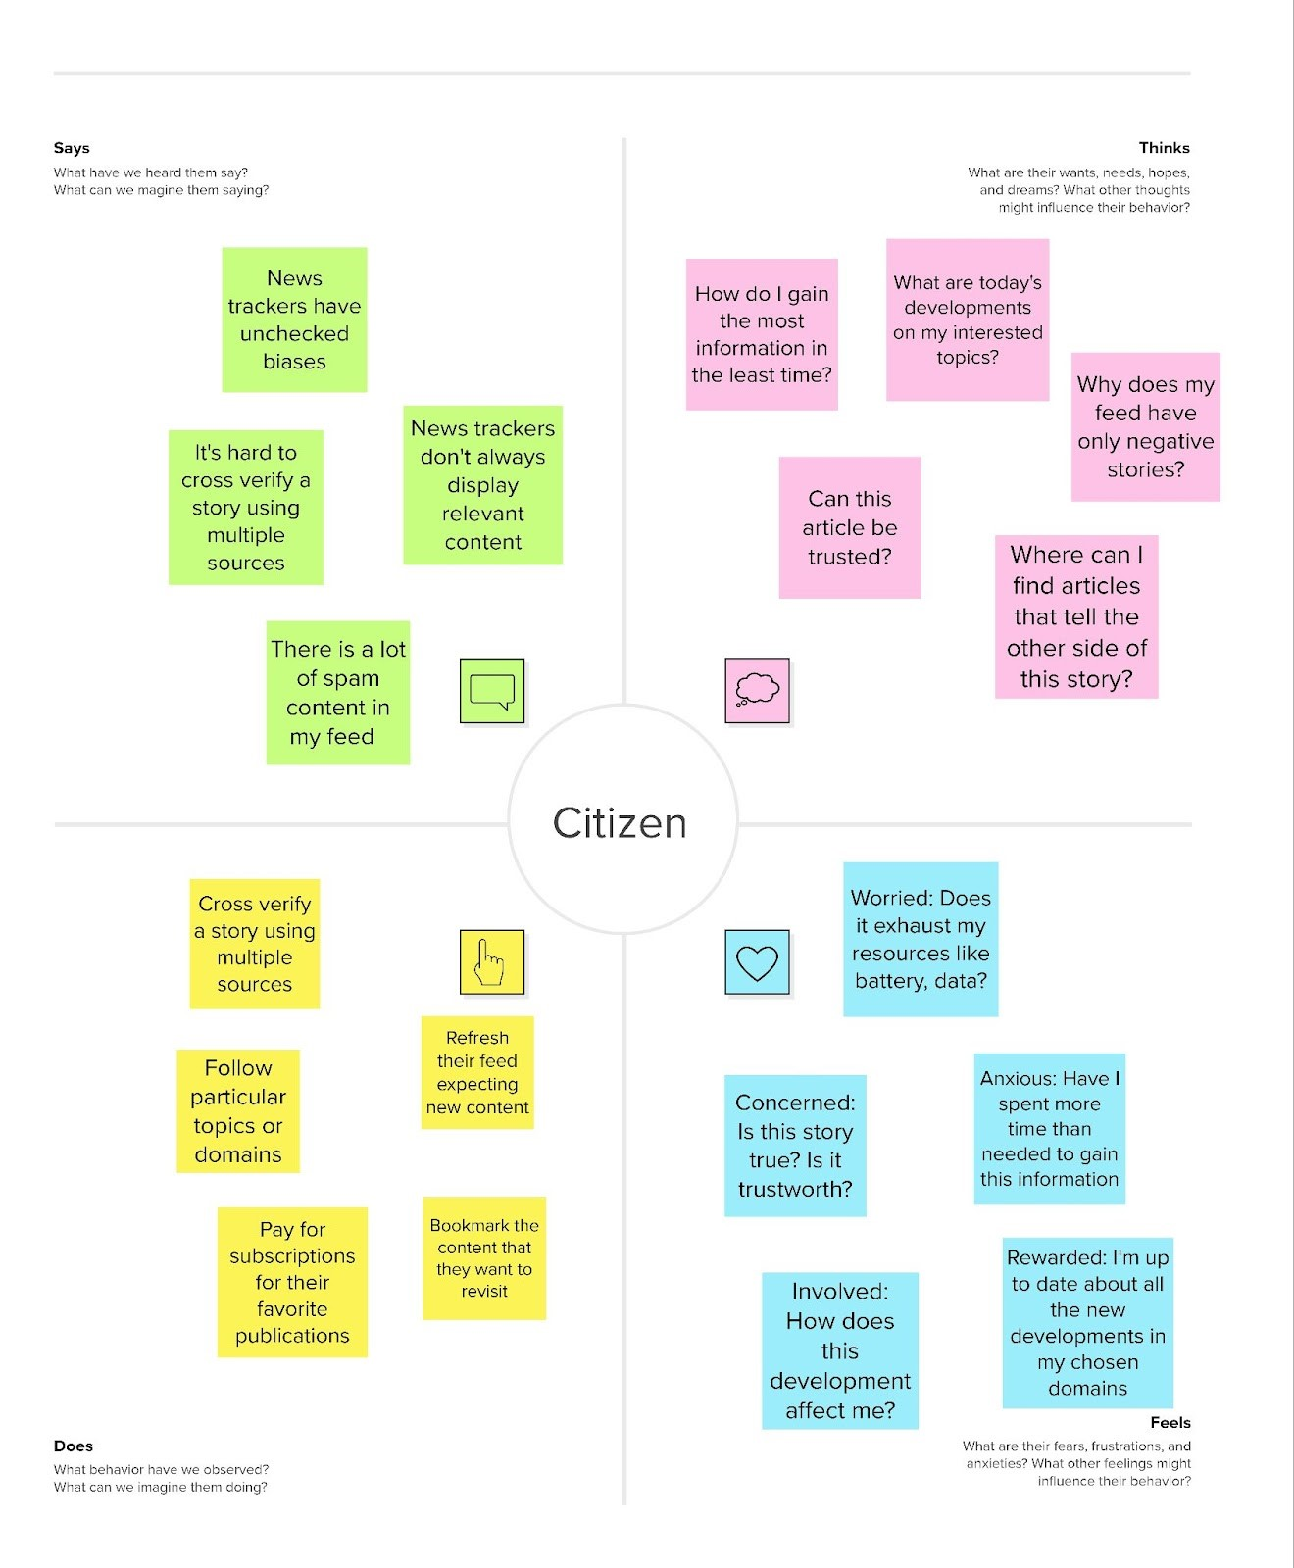

## 3.2 Ideation and Brainstorming

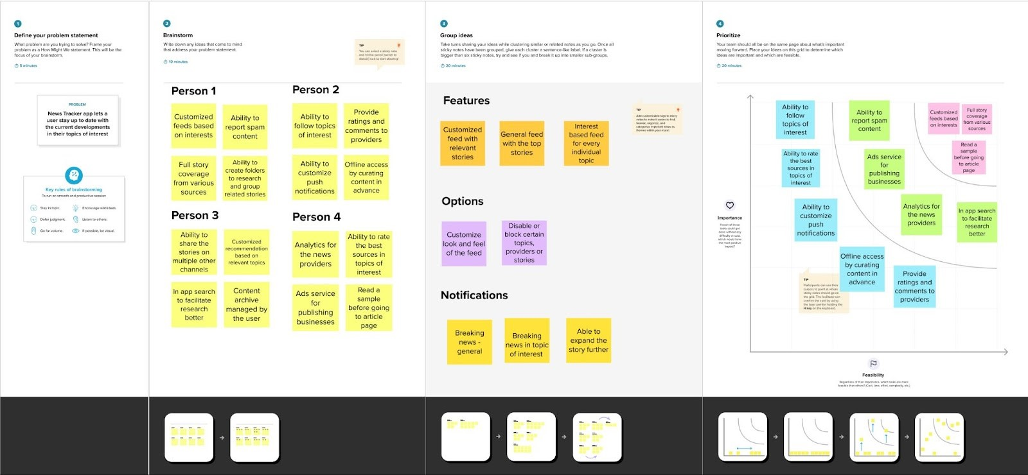

**3.3 Proposed Solution:**

|  |  |  |
| --- | --- | --- |
| **S.NO** | **Parameter** | **Description** |
| 1. | Problem Statement (Problem to be solved) | With lives getting busier by the day, people find it difficult to keep up with current affairs. In some cases, users find it hard to trust the source of the information they read and hence customer base also goes down gradually.  This can be overcome by providing the users curated or personalised content based on their interests and Subject Matter Experts can be brought in to determine if the sources are credible or not. |
| 2. | Idea / Solution description | Several events occur globally. Users find it cumbersome to search for topics or specific articles. This system will allow users to select a few topics or domains and they will be provided a feed with articles  and reports from those domains. |
| 3. | Novelty / Uniqueness | The credibility of the sources mentioned in the feed cannot be determined without the verification of content by Journalists, Reporters and Subject Matter Experts. The system’s feed will be void of falsified and misleading reports and articles. |
| 4. | Social Impact / Customer  Satisfaction | News readers have reduced because of increasing falsified information and misleading titles in reports.  Giving them an accurate report of the event will increase customer base, resulting in an increased level of general knowledge amongst the general populous. |
| 5. | Business Model (Revenue Model) | Website Monetisation by allowing Web Banners can increase the revenue generated.  Providing a subscription based premium articles and removing advertisements similar to Harvard Business Review. |
| 6. | Scalability of the Solution | The application is designed and constructed using a scalable architecture. Hence, the system will be able to meet any amount of expected traffic, working seamlessly across pages. |

## 3.4 Problem Solution Fit

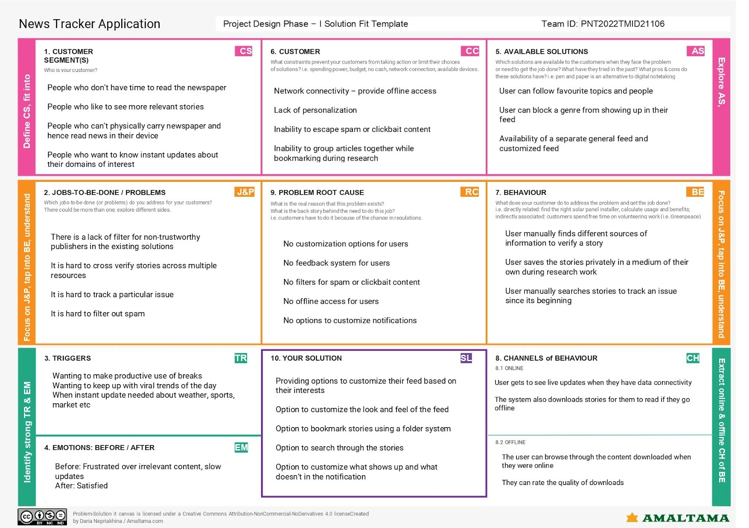

# 4. REQUIREMENT ANALYSIS

**4.1 Functional Requirements:**

|  |  |  |
| --- | --- | --- |
| **FR No.** | **Functional Requirement**  **(Epic)** | **Sub Requirement (Story / Sub-Task)** |
| FR – 1 | User Registration | Registration through Form  Registration through Gmail |
| FR – 2 | User Confirmation | Confirmation via Email  Confirmation via OTP |
| FR – 3 | Find Content based on Topic and Region | Users should be able to find articles or content based on the region they are in or using a search bar for content based and region-based searches |
| FR – 4 | User – friendly Ads | Advertisements are great revenue generators and they should be displayed as web banners. |
| FR – 5 | Real time news updates | An auto refresh feature should be enabled for users to read latest content without a lapse in time |
| FR – 6 | Allowing subscriptions and registrations | Adding subscription feature and registrations can be used to track user’s loyalty and the type of content they’re interested in |

**4.2 Non-functional Requirements:**

|  |  |  |
| --- | --- | --- |
| **FR No.** | **Non-Functional Requirement** | **Description** |
| NFR-1 | **Usability** | * Simple and elegant User Interface * The feed and content should be aligned well and application should be responsive to all devices |
| NFR-2 | **Security** | * Strong password requirements should   be set   * Two-step verification for every login * No sensitive data should be stored |
| NFR-3 | **Reliability** | ● The content of the feed should be verified by reporters |
| NFR-4 | **Performance** | * Seamless and smooth transition of pages * Low lapse of time in case of lower end devices |
| NFR-5 | **Availability** | * Web application delivered over the internet * Low downtime for production changes and maintenance |
| NFR-6 | **Scalability** | ● Scalable and simple application that is made available to customers and users |

# 5. PROJECT DESIGN

## 5.1 Data Flow Diagrams

**Data Flow Diagrams:**

A Data Flow Diagram (DFD) is a traditional visual representation of the information flows within a system. A neat and clear DFD can depict the right amount of the system requirement graphically. It shows how data enters and leaves the system, what changes the information, and where data is stored.

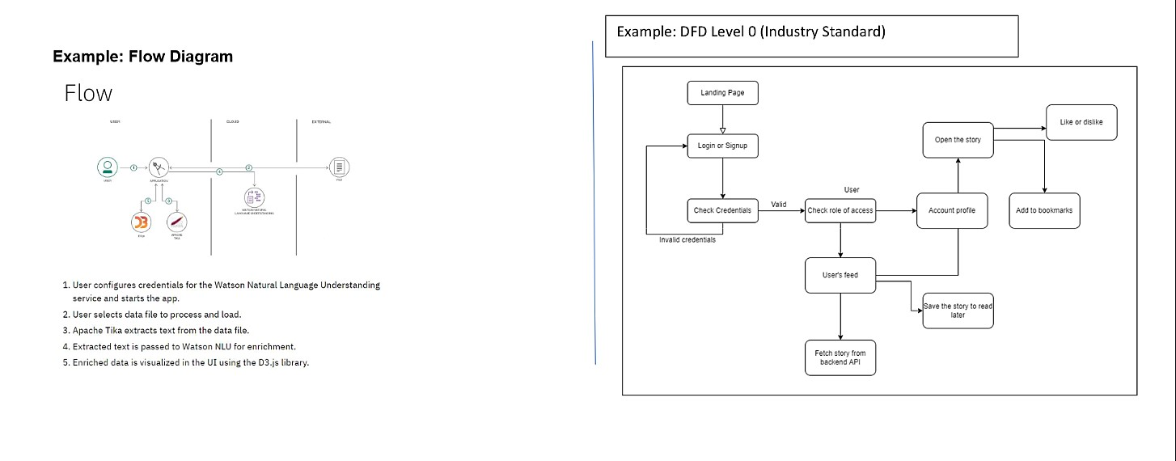

## 5.2 Solution & Technical Architecture

Solution Architecture: Solution architecture is a complex process – with many sub-processes

– that bridges the gap between business problems and technology solutions. Its goals are to: •

Find the best tech solution to solve existing business problems.

* Describe the structure, characteristics, behaviour, and other aspects of the software to project stakeholders.
* Define features, development phases, and solution requirements to the project.
* Provide specifications according to which the solution is defined, managed, and delivered to the customers.

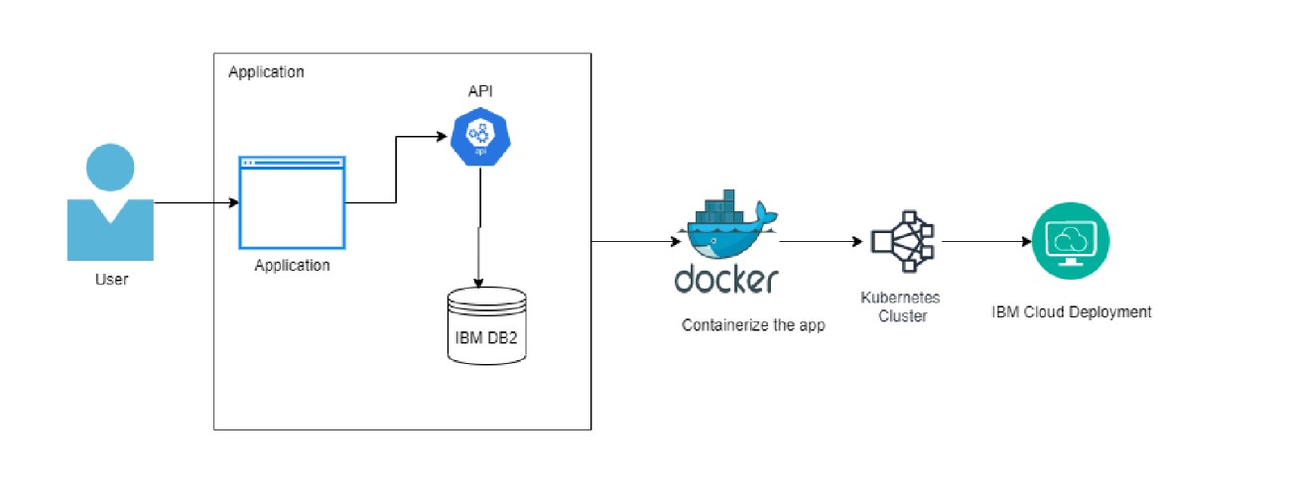

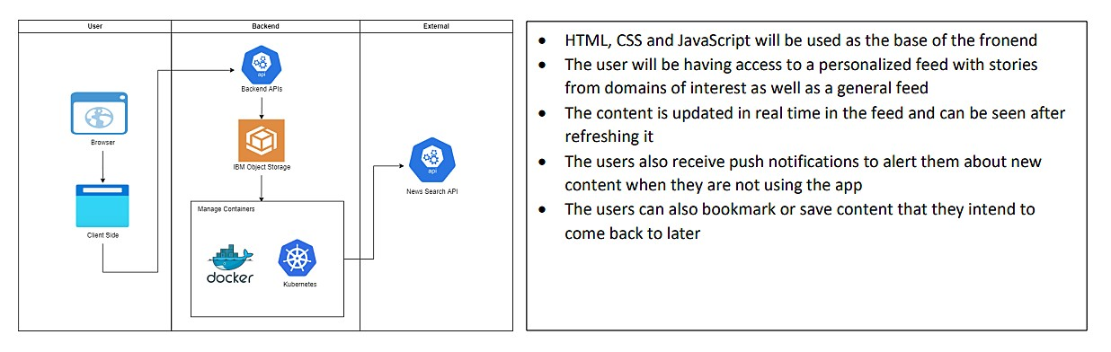

**Components and Technologies**

|  |  |  |  |
| --- | --- | --- | --- |
| **S.No** | **Component** | **Description** | **Technology** |
| 1. | User Interface | The user should be able to access the application through a web browser in a range of devices like desktops, mobile phones, tablets etc | HTML, CSS, React Js. |
| 2. | Application Logic | Logic for the backend processes in the application | Flask (Python) |
| 3. | Database | Data Type, Configurations  etc. | MySQL |
| 4. | Cloud Database | Database Service on Cloud | IBM DB2 |
| 5. | File Storage | File storage requirements | IBM Block Storage |
| 6. | External API | To fetch news articles that are updated in real time | News Search API |
| 7. | Infrastructure (Server /  Cloud) | Application Deployment on  Local System / Cloud  Local Server Configuration:  Cloud Server Configuration : | Docker, Kubernetes. |

**Application Characteristics**

|  |  |  |  |
| --- | --- | --- | --- |
| **S.No** | **Characteristics** | **Description** | **Technology** |
| 1. | Open-Source Frameworks | Flask | Python |
| 2. | Security  Implementations | IAM controls provided by the IBM cloud | Encryptions, IAM  Controls |
| 3. | Scalable Architecture | 3 tier architecture | IBM container registry,  IBM DB2 cloud |
| 4. | Availability | Distributed cloud, and automatic load balancing with containerization | Docker, Kubernetes |
| 5. | Performance | High performance as a result of load balancing and containerization | Container registry,  Kubernetes |

## 5.3 User Stories

|  |  |  |  |  |  |  |
| --- | --- | --- | --- | --- | --- | --- |
| **User Type** | **Functional Requirement (Epic)** | **User**  **Story**  **Numb** | **User Story / Task** | **Acceptance**  **criteria** | **Priori ty** | **Release** |

|  |  |  |  |  |  |  |
| --- | --- | --- | --- | --- | --- | --- |
|  |  | **er** |  |  |  |  |
| Customer (Mobile user) | Registration | USN-1 | As a user, I can register for the application by entering my email, password, and confirming my password. | I can access my account / dashboard | High | Sprint-1 |
|  |  | USN-2 | As a user, I will receive confirmation email once I have registered for the application | I can receive confirmation email & click confirm | Medi um | Sprint-1 |
|  |  | USN-3 | As a user, I can register for the application through  Google | I can register & access the dashboard with Google  Login | Low | Sprint-2 |
|  | Login | USN-4 | As a user, I can log into the application by entering email & password | I’m redirected to dashboard if entered credentials are valid | High | Sprint-1 |
|  | Dashboard | USN-5 | The updated feed with latest stories fetched from the API are displayed | I’m able to view latest stories in my feed | High | Sprint-1 |
| Customer  (Web user) | Search Bar | USN-6 | Users searches for stories or topic in the search bar | I’m able to view relevant stories in my feed | Medi um | Sprint-2 |
|  |  | USN-7 | Users can apply filters to their searches such as date, publisher etc | I’m able to apply filters to my search results for more accurate results | Low | Sprint-1 |
| Customer  Care  Executive | Chatbot | USN-8 | A functional chatbot can respond to user queries in real time | I’m able to clear my queries with | Medi um | Sprint-3 |
|  |  |  |  | the help of the chatbot |  |  |
| Administrator | Server | USN-9 | Administrator verifies and validates the news available in the database | Fakes and invalid news will be rejected and removed from the database | High | Sprint-4 |
|  |  | USN-10 | Administrator provides news articles with video and audio content | I am able to view the articles with video and audio content | High | Sprint-3 |

# 6. PROJECT PLANNING & SCHEDULING

## 6.1 Sprint Planning & Estimation

|  |  |  |  |  |  |  |
| --- | --- | --- | --- | --- | --- | --- |
| **Sprint** | **Functional Requirement (Epic)** | **User**  **Story**  **Numb**  **er** | **User Story / Task** | **Story**  **Points** | **Priority** | **Team Members** |
| Sprint-1 | Registration | USN-1 | As a user, I can register for the application by entering my email, password, and confirming my password. | 3 | High | Sumanth |
| Sprint-1 |  | USN-2 | As a user, I will receive confirmation email once I have registered for the application | 2 | Medium | Kishore |
| Sprint-2 |  | USN-3 | As a user, I can register for the application through Google | 1 | Low | Lokesh |
| Sprint-1 | Login | USN-4 | As a user, I can log into the application by entering email & password | 3 | High | Prasanth |
| Sprint-1 | Dashboard | USN-5 | The updated feed with latest stories fetched from the API are displayed | 3 | High | Lokesh |
| Sprint-2 | Search Bar | USN-6 | Users searches for stories or topic in the search bar | 2 | Medium | Kishore |
| Sprint-1 |  | USN-7 | Users can apply filters to their searches such as date, publisher etc | 1 | Low | Prasanth |
| Sprint-3 | Chatbot | USN-8 | A functional chatbot can respond to user queries in real time | 2 | Medium | Lokesh |
| Sprint-4 | Server | USN-9 | Administrator verifies and validates the news available in the database | 3 | High | Prasanth |
| Sprint-3 |  | USN-10 | Administrator provides news articles with video and audio content | 3 | High | Kishore |

## 6.2 Sprint Delivery Schedule

|  |  |  |  |  |  |  |
| --- | --- | --- | --- | --- | --- | --- |
| **Sprint** | **Total Story**  **Points** | **Duration** | **Sprint**  **Start Date** | **Sprint End**  **Date**  **(Planned)** | **Story**  **Points**  **Completed**  **(as on Planned**  **End Date)** | **Sprint Release**  **Date (Actual)** |
| Sprint-1 | 20 | 6 Days | 24 Oct  2022 | 29 Oct 2022 | 12 | 29 October  2022 |
| Sprint-2 | 20 | 6 Days | 31 Oct  2022 | 05 Nov 2022 | 3 | 5 November  2022 |
| Sprint-3 | 20 | 6 Days | 07 Nov  2022 | 12 Nov 2022 | 2 | 12 November  2022 |
| Sprint-4 | 20 | 6 Days | 14 Nov  2022 | 19 Nov 2022 | 3 | 19 November  2022 |

## 6.3 Reports from JIRA

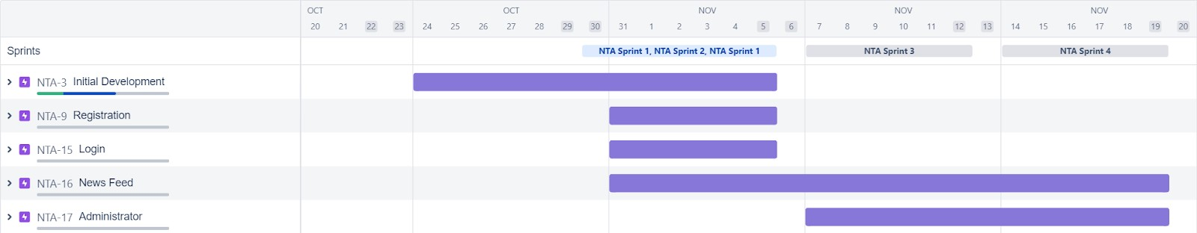

# 7. CODING & SOLUTIONING

## 7.1 Feature 1 - Personalisation

## Verification email Sender

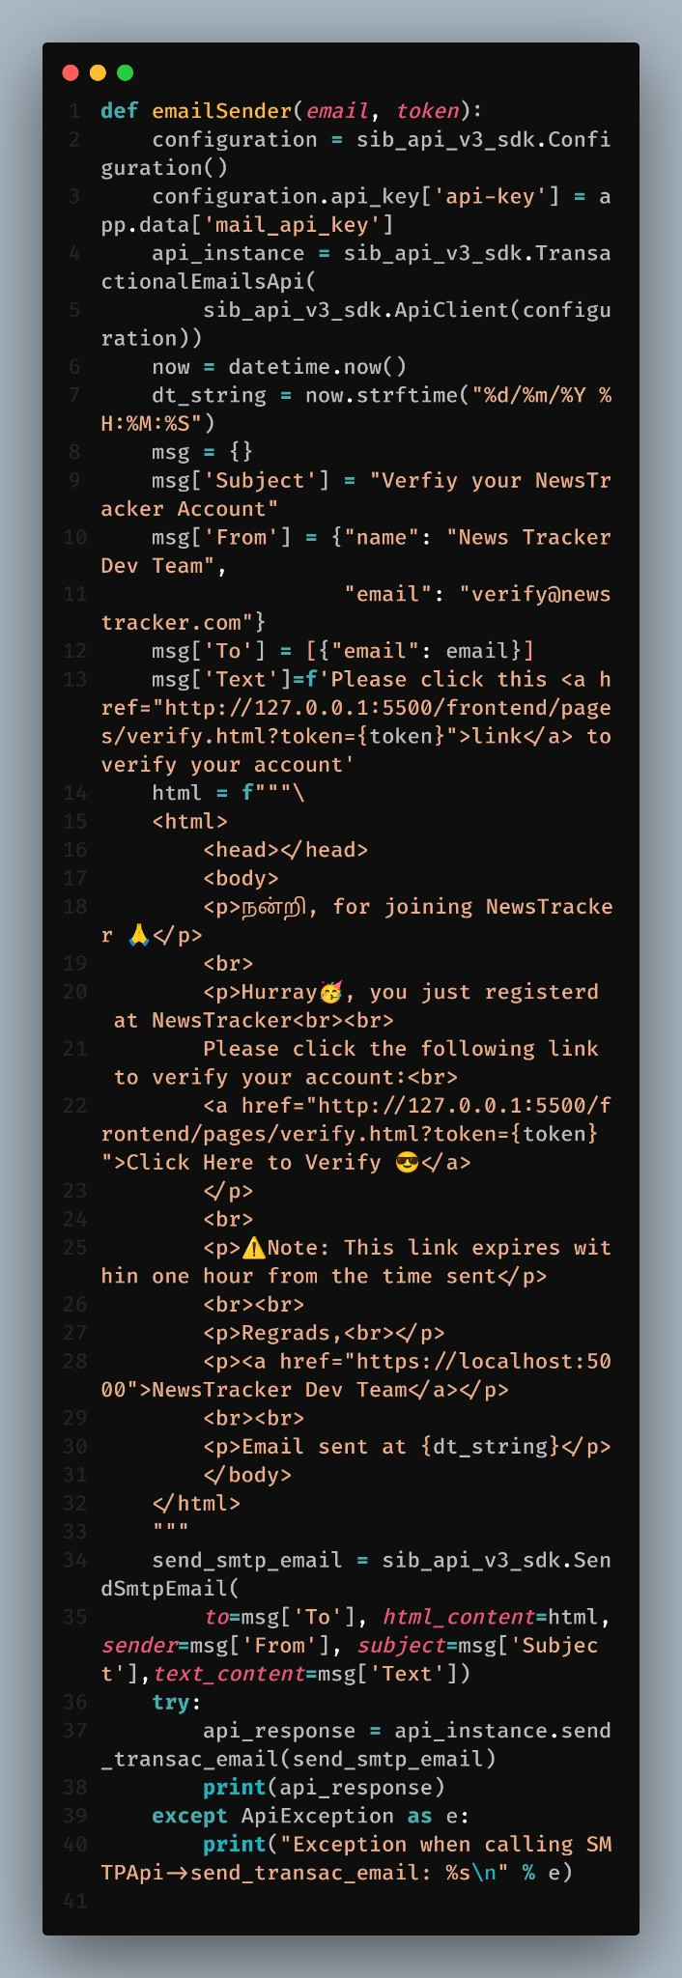

The above function is used to send the verification code to the desired email.

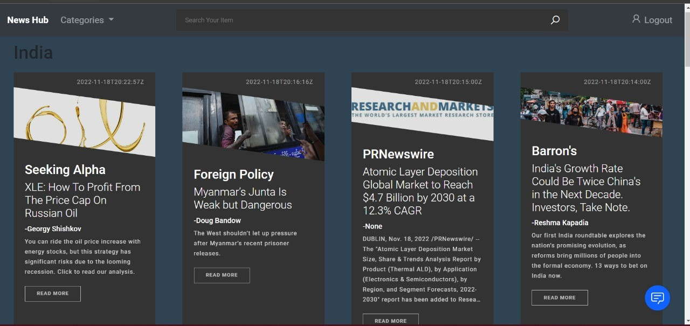

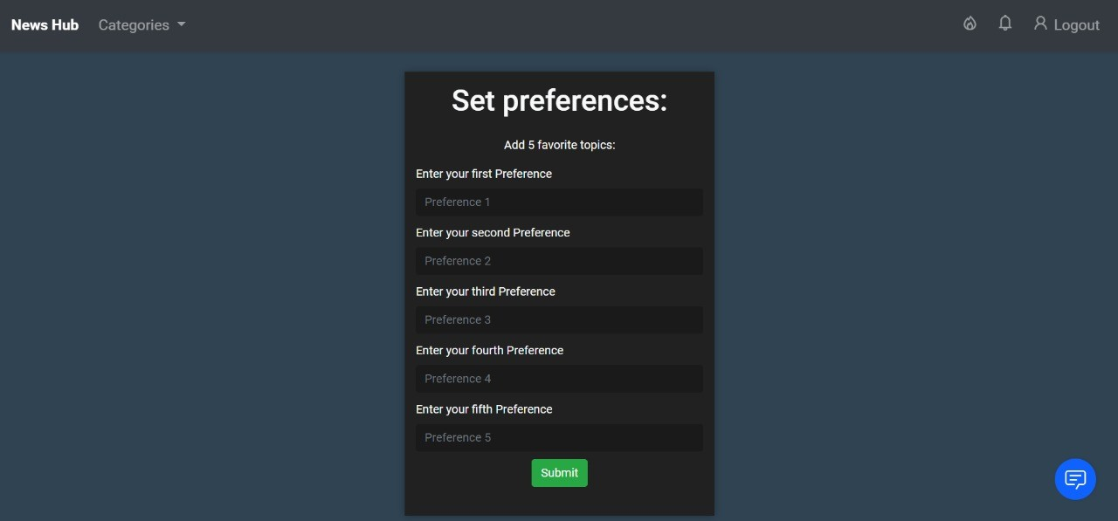

The "set-preferences" allows registered and logged in users (who haven't already set their preferences) to set them up.

This allows the user to read articles based on their preference. The users is made to choose 5 topics of their choice from which the latest articles will be displayed after they login. This gives the user a sense of personalisation and encourages them to visit the application more often.

## 7.2 Feature 2 - Search

## Cookie Checker

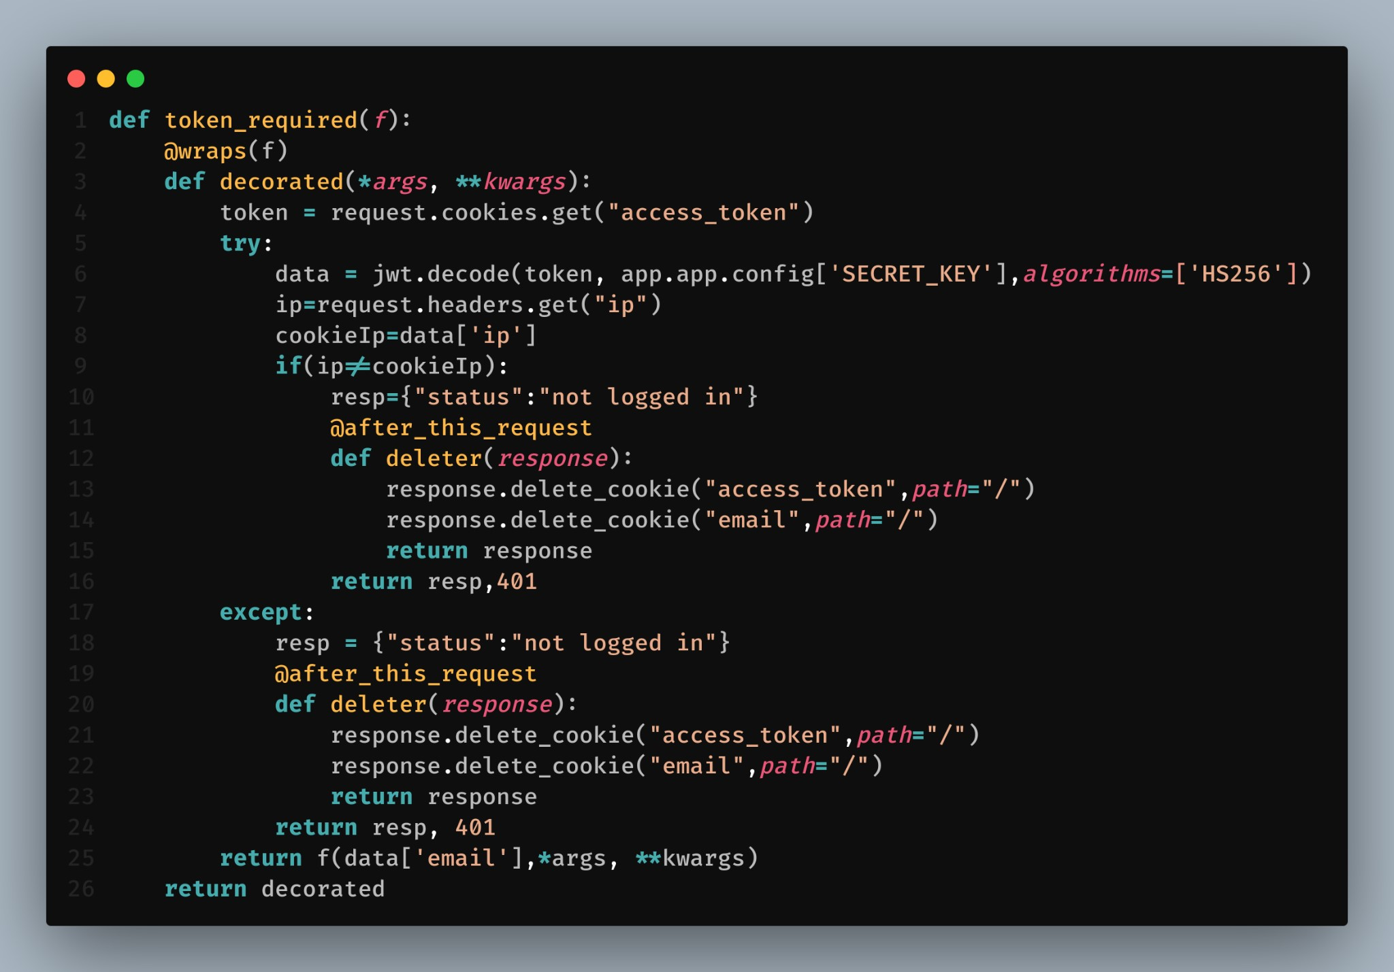

This code is used to check the cookie from the client side and checks whether the user is signed in or not.

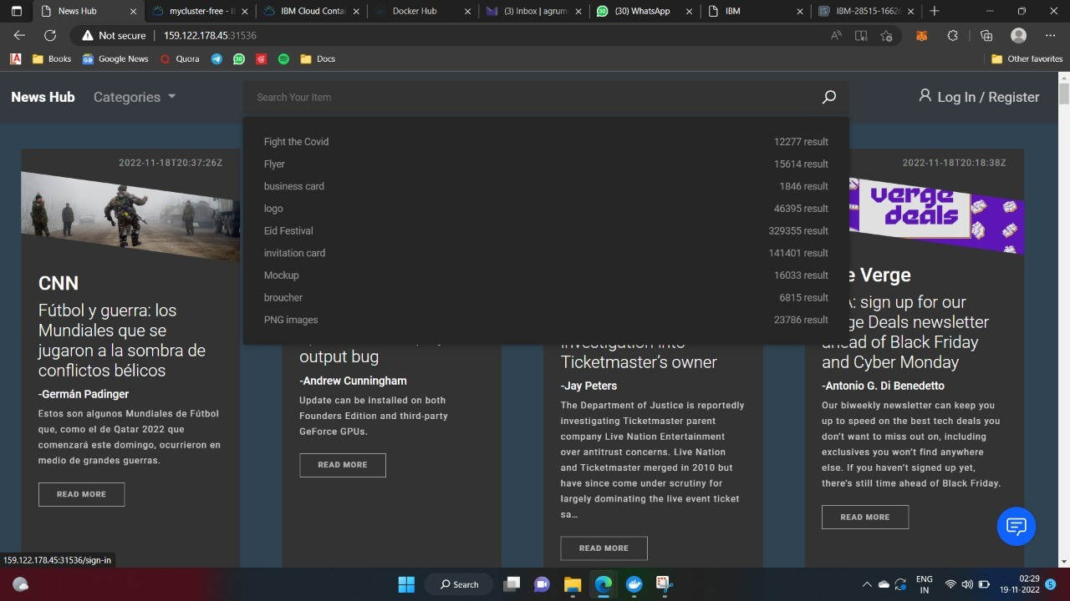

The search bar allows users to search topics, sources and authors of their choice. The news API will fetch the articles based on the query and display them as tiles.

## 3.Database Schema

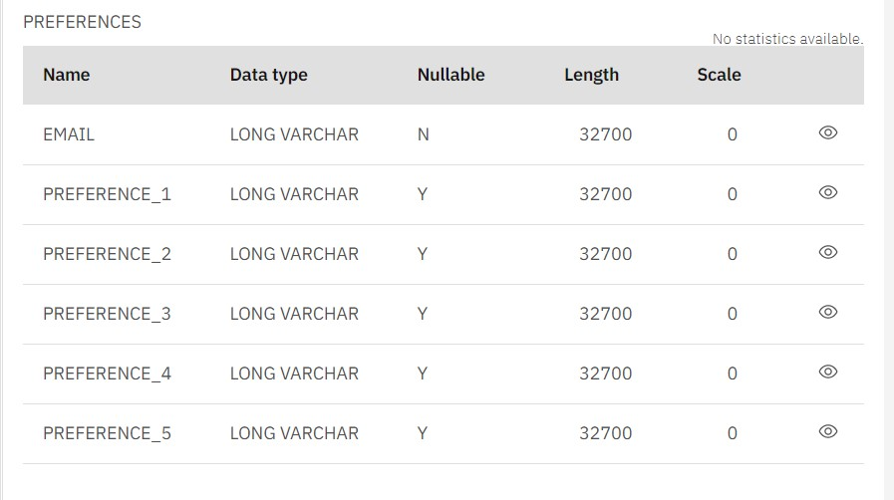

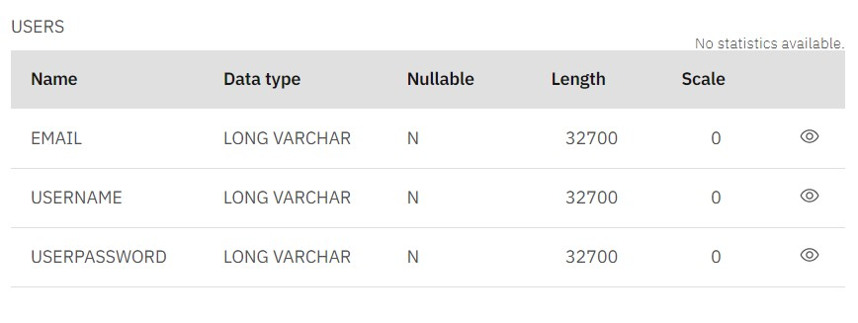

The Users table is used for storing and retrieving user data when they register and login respectively. Users on registering their emails and usernames will be able to track their data throughout the application

The Preferences table is used for setting the user's topics of choice for the landing page. Every user is asked to set 5 topics on their first login and these preferences are set for the user throughout till the user's data is removed.

# 8. TESTING

## 8.1 Test Cases

The Test cases for the News Tracker application are as follows

* Verify If user can Sign up to the account
* Verify If already signed up user cannot log into the account
* Verify if user is able to see Login/Register when clicked on it
* Verify if user is able to filter articles based on categories
* Verify if user is able to see detailed information when clicked on read more

## 8.2 User Acceptance Testing

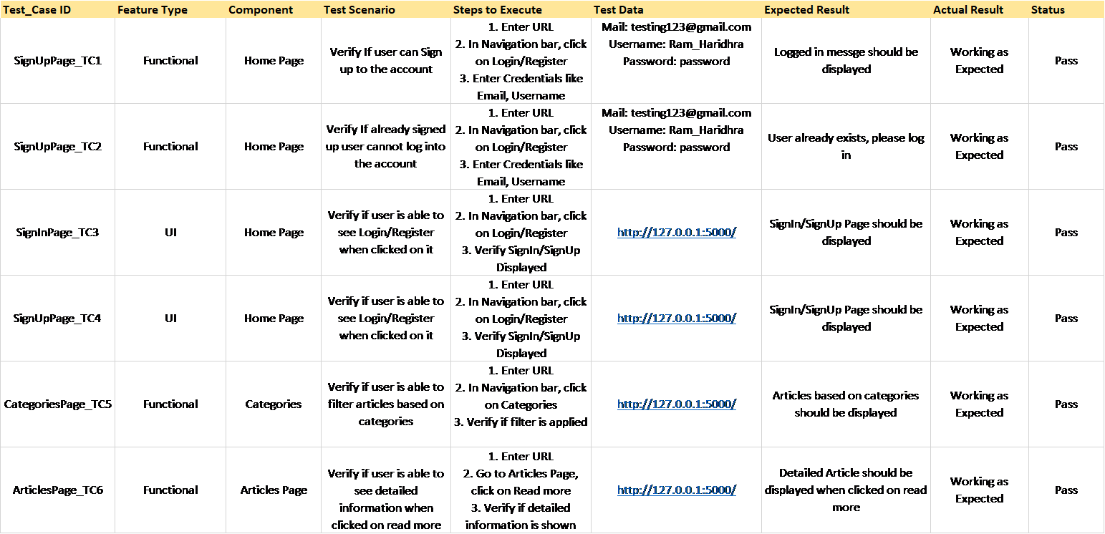

# 9. RESULTS

## 9.1 Performance Metrics

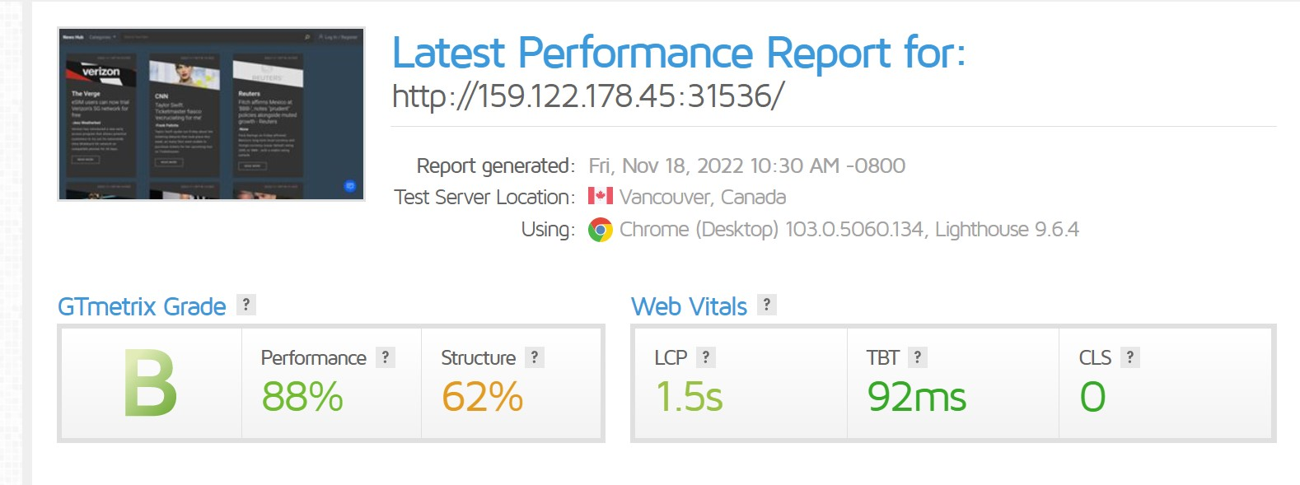

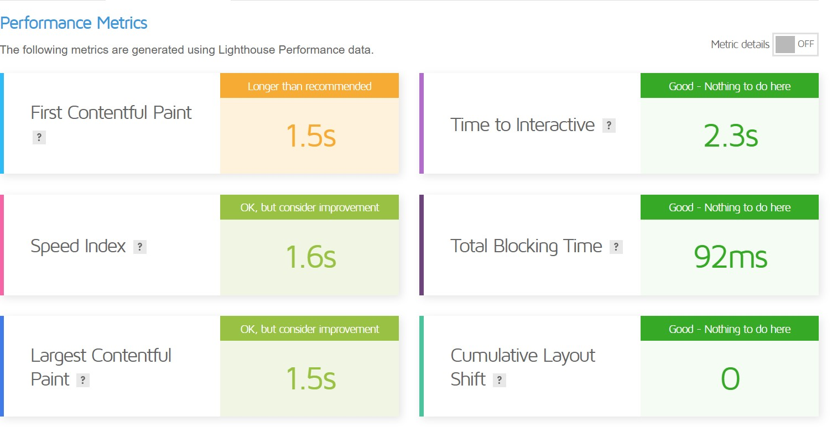

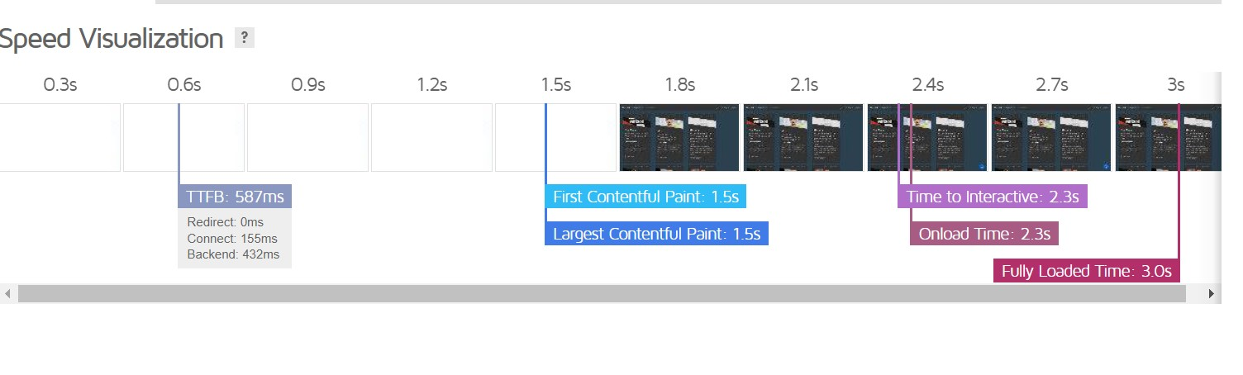

# 10. ADVANTAGES & DISADVANTAGES

## Advantages

* The user's are able to keep track of their favourite sources, categories or authors with a few clicks
* The search bar allows the user to query results based on a large number of options and combinations
* Chatbot integration for assistance in account creation and preference setting
* Multiple categories and endless articles fetched using newsapi

## Disadvantages

* Since the news articles are fetch from an external API, the validity of the data cannot be guaranteed
* Users have to give accurate keywords to search for results

# 11. CONCLUSION

With the help of the internet and external application programming interfaces, it is possible to keep the users informed of the current affairs. With a vast database of articles and references, users are even encouraged to read more.

As news is increasingly accessed on smartphones and tablets, the need for personalising news app interactions is apparent. Users' demands and requirements for personalisation increases day by day. The application's personalisation feature will attract users to spend more time browsing through articles.

And finally, the search bar, will help readers located certain articles based on multiple filters like date, source, language and author to give the users a better user experience.

# 12. FUTURE SCOPE

* Provide filter options for user's to track articles
* Modification and deletion of preferences
* Location based rendering of articles
* Allowing users to report falsified and misleading information

# 13. APPENDIX

**GitHub Link:** https://github.com/IBM-EPBL/IBM-Project-31958-1660206959.git